Pathway of care regarding a birth mark including Congenital dermal melanocytosis (Mongolian blue spots MBS) or suspected medically induced injury (following birth etc)
Bruising in non-mobile children is rare and may indicate abuse or neglect. Birth marks, especially Congenital dermal melanocytosis (MBS) can mimic bruising. Such birth marks are sometimes not being recognised and in particular are often not documented in the child’s records when first seen.
This guidance aims to reduce the number of inappropriate referrals, whilst ensuring genuine bruising is not overlooked. Most birth marks and Congenital dermal melanocytosis (MBS) are often present from birth or may appear during the first weeks of life.
Once noted, it is crucial to document them in the baby’s red book and the health records as soon as possible. Marks and lesions should be drawn on a body map, and a note made of their site, size, colour and appearance. This can be done by the Midwife, GP, Paediatrician or Health Visitor, and allows further examiners to compare their findings with previous observations.
This information should also be included in the discharge notification to GP, Community Midwife and Health Visitor.

Examples of Congenital dermal melanocytosis (MBS)
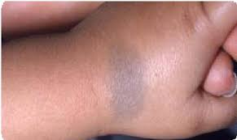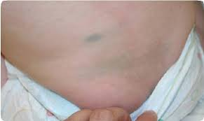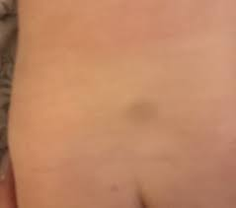
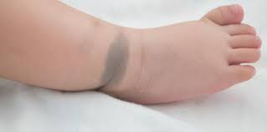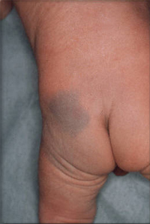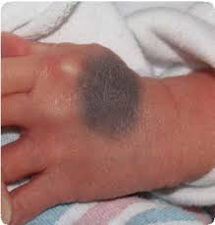

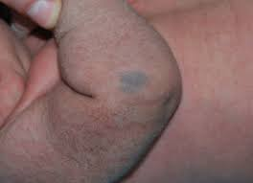
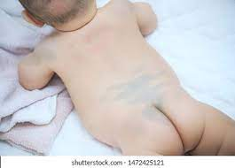
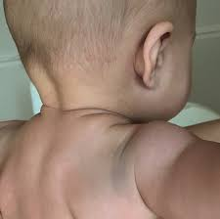

Pathway of care regarding a birth mark including Congenital dermal melanocytosis (Mongolian blue spots MBS) or suspected medically induced injury
Practitioner observes a mark on a child
Practitioner is confident it is a birth mark e.g., Congenital dermal melanocytosis (MBS) or an injury consistent with a medical procedure e.g., cannula/forceps delivery
If there is further concern that it may be a bruise, then immediately:
What are Congenital dermal melanocytosis (MBS)?
- Hyperpigmented skin areas. Usually flat not raised, swollen or inflamed
- Usually present at birth or develop soon after
- Often familial
- Common in children of Asian/African descent and rarer in Caucasians
- Normally uniform blue/slate-grey in colour
- Usually round/ovoid but can be triangular, heart-shaped or linear
- Can be single or multiple marks
- Usually on the lower back/sacrum/buttocks/ upper legs but can appear anywhere.
- Trunk, extremities (rarer), Face or scalp (extremely rare)
- Gradually fade over many years
If it is a birth mark or Congenital dermal melanocytosis (MBS) record mark in child health records and request review within one week.
GP Assessment
Differentiation Mongolian Spots from Bruising:
- Typical sites
- Non-tender
- Usually homogeneous in colour
- Don’t change colour and take months/years to disappear
- Must always document presence of Congenital dermal melanocytosis (MBS), including how extensive, site and shape.
(refer to photographs for examples)
If not recorded, document mark/s using body map in child health records and notify GP, Community Midwife and Health Visitor
Action:
Check Medical / Health Records to see if previously recorded. If it has been recorded no further action is required.
If there is no record of the mark, seek advice and support from a more experienced colleague e.g. Health Visitor, GP, or Paediatrician. This must be within 24hrs. Consider any other concerns/risk factors.
Action:
Check Medical / Health Records to see if previously recorded. If recorded, no further action is required.
Practitioner is concerned that it may be a bruise rather than birth mark or a Congenital dermal melanocytosis (MBS) or due to a medical procedure
Practitioner thinks it is likely that it is a birth mark, Congenital dermal melanocytosis (MBS) or injury consistent with a medical procedure but is unsure.
Action:
Follow the Multi agency procedure for Bruising in Non-Mobile Infants/ Children, referring to Children’s Social Care who will arrange a Child Protection Medical

