Early Help Assessment and Plan
Early Help is about having a good quality conversation with a child, young person or family about different aspects of life such as home, work, school/college, social/community and health and wellbeing. The focus is on what’s working well and what can be done if things need to improve. These quality conversations need to happen as early as possible. Use this form to record the detail of your conversation and to help you to start plan for the future. Once completed, please return to: earlyhelpplan@newcastle.gov.uk
Section 1 – Information gathering

Basic Details: Family Information
Family Name:
Family Address:

Post code:
Best contact number(s):

Basic Details: Family members *please add extra rows where needed. PR = Parental responsibility
Name | Relationship |  | Date of Birth/ Expected Date of Delivery | Gender  (F or M) | Ethnic Origin | Disability or  Additional Needs | Early Help Number | NHS Number
 | Parent / Carer | PR?  ☐
 | Parent / Carer | PR?  ☐

Further information about the Children and Young People *please include information on all children
Child/Young Person’s first language: | Parent(s) first language:
Child/Young Person’s Religion: | Parent’s Religion:
Is an interpreter or signer needed? Has this been arranged? Yes ☐ No ☐
Immigration Status: Refugee ☐ Asylum Seeker ☐
Do any of the children/young people have a caring responsibility? Yes ☐ Details:
Are any of the children/young people privately fostered? Yes ☐ Details:

Details of non-resident parents, any significant family members or friends not living in family home
Name | Date of Birth | Relationship | Address (if different to family address)

Details of Person Completing the Assessment and Plan
Name of Worker
Role
Organisation
E-mail address
Best Contact Number

Which services / practitioners are already working as a Team Around the Family?
Details of workers to involve in the Early Help Assessment and Plan. Health and Education links are mandatory.
Please remember to list any Adult Services workers as well.

Worker Name | Role | Team and Organisation | Telephone number/  e-mail address | Family Member(s) they are supporting | Lead
 | School / Early Years Setting |  |  |  | ☐
 | 0 – 19 Service |  |  |  | ☐
 | GP |  |  |  | ☐
 |  |  |  |  | ☐
 |  |  |  |  | ☐
 |  |  |  |  | ☐
 |  |  |  |  | ☐
 |  |  |  |  | ☐
 |  |  |  |  | ☐
 |  |  |  |  | ☐

Section 2 – Assessment
What has led to you undertaking this assessment?

Section 2 – What are we assessing?

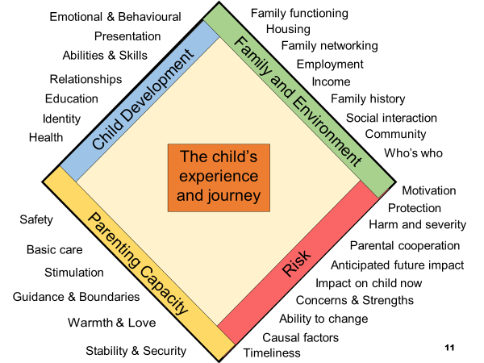

Section 2 – Assessment Continued

Family Needs

Please specify whose views you are recording and who they are referring to

What are we worried about?  Please refer to the assessment diamond above. | What’s going well?  Please refer to the assessment diamond above. | How will we know things have improved?  (outcome to be listed in Section 3)
Please ensure you include the voice of the child and what life is like for the child / children in the family.
Parenting capacity (looking after your child)

Child Development (your child growing up)

Family and the Environment (your family and things happening around you)

Continues over…

Section 2 – Assessment Continued

Family Needs

Worry statements (who is worried, what are they worried about, what could the impact of these worries be on the child / family?)

Section 3 – The Plan
Outcome  Choose only the outcomes that fit this family and personalise them to their needs | Action | Who | By When
1.Parents and Children getting into trouble with the Police.

2. Children who have not been going to school regularly

3.Children / Families who need help

4. Parents or young people without a job or struggling with money or debts.

5. Families where there has been domestic violence

6. Parents and Children with health problems.

Team Around the Family Date:

Time: | Venue:

Section 4 – Information Sharing

Information Sharing Agreement
Early Help is a way of describing the extra support available to families. The information the Team around your Family shares, and that is included in the assessment and plan, is to help you and your family access support. Working with the Team around the Family supporting you is voluntary. The Early Help Assessment and Plan is logged with Newcastle City Council who will make sure that the information is held securely and will only use it in accordance with the law. You can find more information about this at www.newcastle.gov.uk/earlyhelp

In order to participate in the Early Help Assessment, please read and sign below.
- I agree to the Early Help Assessment taking place, I am aware that it is voluntary, and I can withdraw at any point.
- Information that is relevant to my child, children’s or my needs will be recorded and securely stored as a paper or electronic file.
- I understand that the practitioners detailed in the Early Help Assessment and Plan will be contacted to gather information for the Early Help Assessment and Plan. The information on the Early Help Assessment and Plan will be shared for the purposes of providing services and meeting my child/children’s needs.
- Early Help Assessment and Plan documentation may be used by Newcastle City Council for audit and quality assurance purposes and to track outcomes.
- I am aware that practitioners have a legal responsibility to inform Children’s Social Care should there be reason to believe that a young person/child is suffering or is at risk of suffering harm.
https://www.newcastle.gov.uk/your-council-and-democracy/open-data-and-access-to-information/privacy-policy

Parent signature: |  | Child/Young Person signature:
Date: |  | Date:

Parent signature: |  | Child/Young Person signature:
Date: |  | Date:

Worker signature: | Please ensure you log the Early Help Assessment and Plan and review documents with the Early Help Access Point earlyhelpplan@newcastle.gov.uk 0191 211 5805
Date:

