Keeping Safe in Newcastle:
Tell us what you think
We would really like your views
How do we put together the Newcastle Safeguarding Adults Board Strategic Plan?
Information is gathered by engaging with communities and examining a range of data, including previous safeguarding adult’s information to identify the important and concerning issues in Newcastle. The NSAB has previously identified 6 main areas of focus;
Empowerment - Individuals will be asked what they want the outcomes from the safeguarding process to be and these outcomes will directly inform what happens wherever possible.
Protection - Individuals will get help and support to report abuse and neglect.
Proportionality - Individuals will be confident that professionals will work for their best interests and that professionals will only get involved as much as needed.
Prevention - Individuals will receive clear information about what abuse and neglect is, how to recognise the signs and what they can do to seek help and support

Partnership - Individuals will be confident that professionals will work together to get the best outcomes for them.

Accountability - Individuals will receive timely help they need from the person or agency best placed to provide it.
How can you help us? Every year we are required to refresh this strategy and it is important for us to know what your views are so we can include them in our future plans. We are therefore interested in hearing your views about keeping safe in Newcastle.
Thank you for your contribution

Newcastle Safeguarding Adults Board (NSAB) vision statement;
“Our vision is to ensure that Newcastle is an increasingly safer city for adults at risk of abuse and neglect.”
Newcastle Safeguarding Adults Board
The Newcastle Safeguarding Adults Board is a statutory multi-agency partnership responsible for safeguarding adults from abuse and neglect. There are a number of agencies including the Council, Health Services and the Police, that are under a legal duty to work in partnership and sit on the Board.
What do these agencies do?
The agencies are under a legal duty to work together to;
- Develop and publish a strategic plan to safeguard adults at risk from abuse and neglect
- Publish an annual report detailing how effective the Board is
- Carry out Safeguarding Adults Reviews to learn lessons and prevent abuse and neglect
- Raise awareness of what abuse is and where to report it
- Respond to reports of abuse or neglect proportionately
- Work together to prevent abuse from happening where possible

As part of this duty they must draw up a plan setting out their priorities and planned responses.

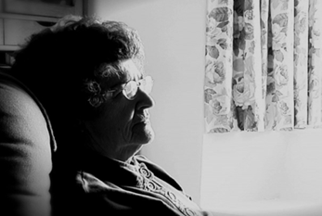

What are the top three priorities you think Newcastle Safeguarding Adults Board should be concentrating on next year?

Is there anything else you would like to tell us about keeping adults at risk safe in Newcastle?

Thank you for your time, we value your contribution

Thank you again or your contribution

