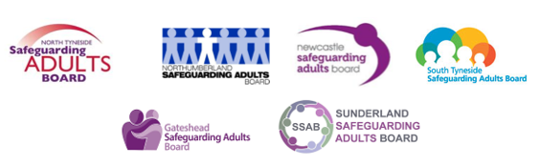

MISSING ADULTS PROTOCOL – Northumbria

February 2022

DOCUMENT CONTROL SHEET

Title – Missing Adults Protocol - Northumbria
Purpose - To provide guidance to police and partners about the joint response to adults at risk of or who have gone missing
Target Audience - This document is intended to be used as a guide for front line practitioners across agencies who work with adults who have care and support needs
Date Approved – November 2020
Review Date- February 2022
This should be read alongside – Northumbria Police Missing from Home Policy and Protocol and College of Policing Approved Professional Practice for Missing. This document is compliant with Safeguarding Adults Guidance
Leads/ Authors - DI Lynne Colledge- Northumbria Police; Carole Paz-Uceira – Safeguarding Adults Business Manager – Gateshead Council
Consultation- Police- FOM, Missing From Home Coordinators, Harm Reduction Units, Local Authorities – Safeguarding Adult Business Managers, Clinical Commissioning Groups – Designated Nurses, Safeguarding Adult Boards

CONTENTS
- Introduction…………………………………………………………………………………………………..3

- Context………………………………………………………………………………………………………….4
  - Definition of Adult Missing…………………………………………………………………4
  - Increased risk factors for missing episodes…………………………………………4

- Pre-Reporting Information Gathering…………………………………………………………….5

- Northumbria Police Response………………………………………………………………………..6
  - Initial THRIVE assessment…………………………………………………………………..6
  - Risk assessment………………………………………………………………………………….7
  - Initial incident report………………………………………………………………………….8
  - Initial assessment……………………………………………………………………………….9
  - Police powers in relation to searching addresses for Missing Persons..9

- Local Authority Response (Incorporating Statutory Safeguarding Adult…………9
S42 Enquiries)
  - Safeguarding adults response…………………………………………………………….9
  - Responses outside of the safeguarding adults framework………………..10

- Post Missing Engagement…………………………………………………………………………….11
  - Northumbria Police Prevention Interview…………………………………………11
  - Post missing wellbeing, engagement and information sharing………….12
- Repeat Incidents (Winnie and Herbert Protocols)………………………………………..13
Appendices
Appendix 1 – Flowchart of responsibilities: Planning and response if someone is not where they are expected to be…………………………………………………………………15
Appendix 2 – Return Home Interview template…………………………………………………18
Appendix 3 – Local Referral Pathways template………………………………………………..23

The Herbert and Winnie Protocols can be downloaded from the Northumbria Police website here

- INTRODUCTION
Adults that go missing are often a concern for all partners involved within Safeguarding Adult Boards. Going missing can be an indicator that a person may be at risk of harm. The reasons for a person to go missing are complex and could be linked to a range of personal, family or social issues.
It is recognised that a person over 18 years may be missing with no risk through their own choice. Their right to privacy must be observed and details of their location not divulged if this is their expressed decision. If there are however concerns about the safety and well-being of the person or others, a decision may have to be taken to share the details of the location with relevant agencies and within the context of statutory duties and powers to enable safeguarding actions to be taken (e.g. assessment under the Mental Health Act (MHA) or Mental Capacity Act (MCA).
There are specific concerns for adults who have needs for care and support who go missing and the potential risks of exploitation and significant harm.
This protocol has been developed between Northumbria Police and six Safeguarding Adult Boards- Northumberland, North Tyneside, Newcastle, Gateshead, South Tyneside and Sunderland.
It is designed to ensure a consistent approach across the Northumbria Police Force footprint and recognises that the missing episode of a vulnerable adult requires a multi-agency response. Sometimes this will require a safeguarding adults response, sometimes it will require multi-agency responses outside of safeguarding adults procedures. The protocol builds upon Northumbria Police and partner agency policies and processes and is designed with the intention of reducing missing episodes among adults and improving opportunities to safeguard them. The intention is to provide the best possible service to adults who are missing or at risk of going missing.
Multi-agency support is vital for: effective risk assessment; to address the reasons why people go missing; provide the necessary help when it is needed; and reduce the likelihood of future missing episodes. Police are necessarily involved in missing person investigations at the point of reporting, conducting the search and when a person is found. However, providing an effective response to missing adults is not the responsibility of the police alone.
This document should be read alongside the 2020 Multi-Agency response for adults who go missing from health and care settings – A National framework for England.

- CONTEXT

  - Definition of Adult Missing
This protocol uses the National Multi-Agency definition of a Missing Adult:
A missing person is anyone whose whereabouts can’t be established and:
- The context suggests the person may be a victim of crime; or
- The person is at risk of harm to themselves or another; or
- Where there is particular concern because the circumstances are out of character, or there are ongoing concerns for their safety because of a previous pattern of going missing
  - This is not the national police definition of a missing person as a need has been identified for a more specific version for the purpose of multi-agency understanding. The police definition allows for a broad range of circumstances within which the police can make an assessment of risk and decide appropriate action. This multi-agency definition aims to provide more clarity on the circumstances that should trigger action by professionals to find and safeguard someone by including the context of risk.

b. Increased risk factors for missing episodes
There are many reasons why an adult might go missing. The common types of missing adult episodes within the Northumbria Police force area are:
    - Missing from Hospital Settings
Due to the high proportion of missing adults from Hospital Settings, Northumbria Police have specific joint working protocols for missing from Acute Hospitals and Mental Health Hospitals.
    - Mental Health
Approximately 30% of missing adults in the Northumbria Police Area have a mental health flag. Missing episodes relating to mental distress are a large proportion of the missing adult reports which are dealt with by Police. It is important that a multi –agency problem solving approach is established to tackling the root causes of these missing episodes which could be linked to a range of social and family issues.

iii) Dementia
There is a risk that adults living with dementia can get lost and go missing. Northumbria Police and the Northumberland, Tyne and Wear Safeguarding Adult Boards have embedded the nationally acclaimed Herbert Protocol. This encourages carers to record useful information which could be used in the event of a vulnerable person with dementia going missing. Carers, family members and friends can complete the Herbert Protocol form in advance, which records all vital details, such as medication required, mobile numbers, places previously located, a photograph etc.
iv) Care Leavers
Missing adults between the ages of 18-25 who were previously in looked after care are recognised as particularly vulnerable to missing episodes and associated exploitation. Typically, these cases require close liaison with Local Authority Children and Adult services and sharing of information from the MSET (Missing, Slavery, Exploitation and Trafficked) process if the person had a history of missing episodes as a child.

There are many other known factors that can contribute to an increased risk of an adult going missing. These include (but are not limited to):
- Living in supported accommodation – Adults who live in supported accommodation are more likely to go missing due to a multitude of factors including substance misuse, associations and risk of exploitation. Many supported accommodation providers have a policy of contacting the police to raise a missing persons report after a set timescale such as 48 hours. It is more important that residents within supported accommodation provision are appropriately assessed for the likelihood of going missing and the specific risks associated with being missing assessed on each occasion for that individual. Those risks will vary considerably for each resident.
- Substance misuse – Adults are more vulnerable to all types of exploitation and missing episodes whilst misusing substances. Vulnerability increases whilst under the influence of substances, and when trying to obtain money to buy substances.
- Domestic abuse – Domestic abuse can be extremely complex and increase the risk of adults going missing for a myriad of reasons. This could either be either the victim going missing, the perpetrator, or in some circumstances it could be both together. Coercion and / or control should always be considered as a contributory factor.
- Learning Disability / Autism / ADHD – According to the charity Missing People, reasons for adults with a Learning Disability going missing could include bullying / harassment, poor physical and mental health, difficulties in engaging with the police and other agencies, lack of suitable accommodation / homelessness, medication issues, addiction, language and communication issues, behavioural problems, transport (getting lost) and meeting strangers online. (Rickford 2012: People with Intellectual Disabilities Going Missing)
- Exploitation / Modern Day Slavery – Adults experiencing or at risk of exploitation, including Modern Day Slavery, are at increased risk of going missing. They may be missing due to experiencing harm, because they are trying to evade the person (s) who has caused them harm and / or because they do not trust services to help them.

3. PRE-REPORTING INFORMATION GATHERING
Prior to reporting a person missing or expressing a “concern for their welfare” professionals should have made their own initial enquiries as an agency having a duty of care for the individual. Reasonable enquiries which are expected to have been made, where possible / appropriate, include:
- Attempts to contact the individual by telephone and in person at their home address
- An initial search of the place they are being reported missing from
- Contact with known next of kin, family members or associates as to their whereabouts (unless not in their best interests)
- Contact with Multi-Agency Safeguarding Hub for details of any other professionals involved in their care
- Medium and High-risk Missing Person cases are investigated around the clock. A nominated point of contact from the reporting agency is required who can be accessible to provide further information to police 24 hours a day
- If the person is subject to a court or hospital order this should be made available to police
It is important that initial information is gathered prior (except in imminent risk to life cases) to contacting Northumbria Police, the relevant Local Authorities or making a Safeguarding Adult Concern.
It should be noted that any calls reporting concerns for a person’s welfare to police will likely generate a missing person enquiry if their whereabouts cannot be quickly established. Consideration needs to be given as to whether the risks to the individual are so significant that police need to be involved in locating them. Can enquiries be made within your own agency and monitored over a period of time? Adults with mental capacity can make choices regarding their lifestyle and go missing for a variety of reasons and it may be seen as an intrusion into their private life where they are reported missing to police or local authority with no obvious risk to their safety.
The National Framework for Missing Adults includes some useful flowcharts which provide an example of the process that could be followed when professionals have a concern about a person who is not where they are expected to be (Appendix 1). Figure 1 focuses on prevention; figure 2 on reporting a person missing and the investigation; and figure 3 outlines processes when a person returns from missing and monitoring the response for the purpose of improvement.

  - NORTHUMBRIA POLICE RESPONSE
4a. Initial THRIVE assessment
When taking a report of a missing person Northumbria Police Control Room Staff will initially apply (THRIVE) as a risk assessment tool in identifying the appropriate police response.
THRIVE-Threat, Harm, Risk, Investigation Opportunity, Vulnerability, Engagement

4b. Risk Assessment
All missing person reports sit within a continuum of risk from no apparent risk (absent) to high risk cases that require immediate, intensive action.
Level of Professional activity
Northumbria police use the following nationally agreed risk assessment when deciding on the investigation each Missing episode requires:
- NO APPARENT RISK (ABSENT)
There is no apparent risk of harm to either the subject or the public.
Actions to locate the subject and / or gather further information should be agreed with the informant and a latest review time set to reassess the risk.
- LOW RISK
The risk of harm to the subject or public is assessed as possible but minimal.
Proportionate enquiries should be carried out to ensure that the individual has not come to harm.
- MEDIUM RISK
The risk of harm to the subject or public is assessed as likely but not serious.
This category requires an active and measured response by the police and other agencies in order to trace the missing person and support the person reporting.
- HIGH RISK
The risk of serious harm to the subject or public is assessed as very likely.
This category almost always requires the immediate deployment of police resources. Action may be delayed in exceptional circumstances, such as searching water or forested areas during hours of darkness. A member of the Northumbria Police senior management team must be involved in the examination of initial lines of enquiry and approval of appropriate staffing levels. Such cases should lead to the appointment of an investigating officer (IO) and possibly a senior investigating officer (SIO) , and a police search adviser (PoISA).
There should be a press / media strategy and / or close contact with outside agencies. Family support should be put in place where appropriate.
Considerations:
- When taking a report of a missing person, Northumbria Police will consider as to whether a Safeguarding Adults Concern should be raised with the appropriate Local Authority.
- On each occasion where a person is reported within the community as missing and there are concerns about self- harm / suicidal thoughts Northumbria Police Street Triage Team should be contacted to ensure there is information sharing with Cumbria, Northumberland, Tyne and Wear NHS Foundation Trust (CNTW) to accurately assess the risk of harm and subsequent police response.

4c. Initial incident report
On initial report of a Missing Adult to Police the call handler will be expected to obtain the following minimum information:
- Name
- Age
- Description of person
- Description of clothing
- Home address
- Location missing from
- Circumstances of going missing
- Name, address, contact telephone number and relationship to missing person of person reporting. This should include out of hours contact details in case the investigation is ongoing when the person reporting goes off duty
- Details of any vehicle or transport used
- The relevant information concerning the person reporting the disappearance
- Location of where the missing person might be
- Any medication the missing person requires, frequency of taking and the effects if not taken
- Information about known risks, e.g. known to be at risk of exploitation (i.e. criminal, sexual, financial), concerns about physical or mental health, concerns about lacking mental capacity
- Information about any person who might have contact with the missing person, such as people with whom the missing person was found in previous incidents e.g. estranged family, known associates, colleagues.
4d. Initial assessment
They will then conduct an initial assessment asking the following questions:
- Why are you worried about the missing person?
- What has been done so far to trace this individual?
- Is this out of character?
- Have they been missing before? If yes, what happened whilst they were missing, where were they found?
- Are there any specific medical needs?
- Are they likely to become the victim of crime?
- Are they likely to be hurt or harmed?
- Are they likely to self-harm or attempt suicide?
- Do they pose a danger to other people?
- Are they likely to have travelled abroad?
- Is there any other information relevant to their absence?
4e. Police powers in relation to searching addresses for Missing Persons
Where a capacitated adult is found, the police can do no more than confirm they are fit and well at the point in time they are located.
Police can only gain entry to an address under S.17 PACE to “save life or limb”. There must be reasonable grounds to believe that entry is required to effectively save life or prevent serious harm
Stated case of Syed V DPP “Concern for welfare is not sufficient to justify an entry within the terms of s.17(1)(e). It is altogether too low a test”

  - LOCAL AUTHORITY RESPONSE
(INCORPORATING STATUTORY SAFEGUARDING ADULT SECTION 42 ENQUIRIES)

- Safeguarding adults response
If an adult is reported as missing to the Local Authority and they meet the statutory criteria for safeguarding adults, the Safeguarding Adults Multi-Agency Safeguarding Adult Policy and Procedures will be instigated, ensuring that partner agencies are involved where appropriate. In accordance with Section 42 of the Care Act 2014, local authorities must make enquiries or ensure others do so, when there is reasonable cause to suspect that an adult in its area:
- has needs for care and support (whether or not the local authority is meeting any of those needs) and;
- is experiencing, or at risk of, abuse or neglect and;
- as a result of those care and support needs is unable to protect themselves from either the risk of, or the experience of, abuse or neglect
The Care Act 2014 introduced six key principles which underpin all adult safeguarding work. The six principles can be applied to the strategic oversight and operational response to cases of adult missing:
- Empowerment – people being supported and encouraged to make their own decisions and give informed consent
- Prevention – it is better to take action before harm occurs
- Proportionality – the least intrusive response appropriate to the risk presented
- Protection – support and representation for those in greatest need
- Partnership – local solutions through services working with their communities
- Accountability – accountability and transparency in safeguarding practice
Safeguarding adults plans/protection plans devised as a result of a Section 42 enquiry where the person going missing was a feature, might include actions such as:
- completing a trigger plan or appropriate protocol, Herbert, Winnie etc)
- clarity on who will be notified when there is a concern about the person going missing
- assessment of mental capacity in relation to the missing episodes
- consideration of legal powers available e.g. Mental Capacity Act, Mental Health Act, Inherent Jurisdiction
- Flagging the person’s vulnerability on relevant agency records
- Action against any alleged perpetrators, including disruption activity
- Sharing information about the missing person – particularly with the Missing from Home Coordinators within Northumbria Police, Multiple Exclusion Team, Cumbria, Northumberland, Tyne and Wear NHS Foundation Trust and acute hospital trusts.
- Agreeing safety plans with the person to reduce risks should they go missing in the future – e.g. where might be a safe place to go, planning how to get home, ability to communicate with someone for help
- Addressing the reasons why the person might be going missing
- Supporting family members / carers or staff caring for the person who has gone missing

- Responses outside of the safeguarding adults framework

An adult might be reported missing to the Local Authority even if statutory safeguarding adults criteria are not met e.g. the missing person might be receiving a service from the local authority. If an adult is reported as missing to the Local Authority and they do not meet the statutory criteria for safeguarding adults, each individual Local Authority must determine what the appropriate referral pathway would be. This could include, but is not limited to:
- If an adult without care and support needs is missing and there is concern that the individual, and / or other individuals, is experiencing, or at risk of, abuse or neglect then Northumbria Police should be notified (see section 4).
- If the adult is in receipt of social care services but not at risk of abuse or neglect then then the service / allocated worker should be notified
- If the missing adult is a former looked after child and aged 18 -25, then check to see if they have an allocated looked after team worker such as a personal adviser
- Consider local referral pathways. Examples include:
  - Adult social care
  - Housing advice
  - Multi-Agency Safeguarding Hub (MASH)
  - Domestic Abuse support
  - Substance misuse services
Appendix 3 provides a blank template for localities to complete and keep up to date with details of local referral pathways.
  - POST MISSING ENGAGEMENT

- Northumbria Police Prevention Interview
Northumbria Police will carry out prevention interviews for all missing adults reported to Northumbria Police. The Prevention Interview is carried out as part of the found process and is an important step to establishing the reasons for the missing episode and identifies early opportunities to minimise future harm to them.
The questions Police officers ask during a prevention interview are:
1 | Have you come to any harm whilst missing? (Exploitation, sexual offences, violence, self-harm etc.). If ‘Yes’, obtain full details for investigation, record crime and consider forensic evidence.
2 | Why did you go missing? (Factors-abuse, coercion, domestic circumstances, work, financial, mental health issues, just stayed out, drug/alcohol issues etc.)
3 | What have you been doing whilst missing? (Consider thoughts of self-harm, sexual/criminal exploitation, involvement in crime etc.)
4 | How did you arrive at your destination? (picked up by car, bus, etc.)
5 | Did you travel alone or were any other persons involved?
6 | How did you make arrangements? (Facebook, text, calls made, received calls, etc.)
7 | Where have you been? (places stayed/frequented, transport used, vehicle details, etc.)
8 | Who have you been with?
9 | How did you support yourself? (given cash, gifts, food, accommodation, committed crime, etc.)
10 | Have you used drugs, alcohol or other substances whilst missing?
11 | Will you go missing again?
12 | What could prevent you from going missing again?
13 | Do you consent for referral to support services?
There are a myriad of support services available, depending upon the needs of the adult. For example:
- As part of the prevention interview for each Missing Adult where there is an element of immediate mental health crisis Northumbria Police can contact Street Triage to attend and discuss with them any support and referrals which can be put in place.

- All agencies are also able to signpost individuals to Cumbria, Northumberland Tyne and Wear (CNTW) NHS Foundation Trust Crisis Services for support around mental health crisis
Northern- 0800 652 2861 Central – 0800 652 2863 Southern- 0800 652 2867

- Should there be any safeguarding concerns shared within the police missing return home interview, then an Adult Concern Notification should be shared with the consent of the missing person with the appropriate Local Authority If consent is not given this must be respected unless there are clear reasons for overriding the consent.

b.

Post Missing Wellbeing, Engagement and Information Sharing
It is recognised that on some occasion’s police officers in uniform may not always be the most appropriate professional to conduct the prevention interview with a Missing Adult. If another professional is involved with an adult who has had a missing episode, they could complete a return interview using the suggested template in Appendix 2. This would be a supportive interview and would be considered good practice, with the aim of reducing the likelihood of future missing episodes.
Any discussion may identify risk factors, crimes or issues affecting health and wellbeing. Where relevant, information should be shared with appropriate partners. Unless there are reasons to override consent, then consent should be obtained. Sharing information, with the consent of the adult, would be helpful as it would potentially reduce the amount of times that the person is asked similar questions by a number of different agencies
Information from return home interviews should be shared with Police with consent to allow for a problem solving approach to be taken to the Missing episode (Email MissingPersonMailbox@northumbria.pnn.police.uk). The Missing From Home Co-ordinators within Northumbria Police will have a key role in facilitating information sharing across partners and local authority boundaries so that missing people who move across local authority areas are considered with a joined up approach. In addition to cross border information sharing about individual cases Northumbria Police will also share data in relation to Missing adult trends and hotspots with Strategic Groups within Safeguarding Adult Boards to ensure a Strategic response to Missing adults cases. (This was a recommendation from Newcastle Spicer Joint Serious Case Review).
Police officers and partner agencies should always consider if there are other factors involved such as Honour Based Violence, Female Genital Mutilation, Modern Slavery, Exploitation or Forced Marriage and consider that a report of missing can sometimes be made to locate those who are fleeing from harm.
Professionals should recognise the vulnerability a missing episode creates and in order to prevent against future harm should ensure appropriate information, advice, guidance and signposting is provided to a Missing Adult. For any person identified who poses a risk of harm to a missing adult disruption activity should be put in place.
If a missing adult with capacity is found and does not wish their whereabouts to be revealed, the person making the original report should only be told that the missing person has been located and not informed of their whereabouts. Particular care should be taken where there are obvious cultural and religious sensitivities.
The Missing People Charity have an array of services in place to support Missing Adults, their Families and Professionals. Their website can be accessed at www.missingpeople.org.uk

  - REPEAT MISSING EPISODES (Winnie and Herbert Protocols)
It is recognised that repeat missing adults are at risk of harm and it is important for all agencies to apply a preventative problem solving approach to repeat missing episodes.
Within the ‘golden hour’ of a medium / high risk missing episode, it is imperative that as much information is made available as soon as possible to Northumbria Police.
In circumstances where an adult has support from a professional and it is identified they are likely to go missing the Herbert or Winnie Protocol form should be completed.
Practitioners may have also heard of the Philomena Protocol which is a similar process for children in care who may go missing. For children reaching adulthood who have had an existing Philomena Protocol form in place it is important that this is considered as part of the transition process and consideration is given to completing the Winnie Protocol. Children at risk of missing at 17 years are likely to be exposed to the same risks of Missing when turning 18.
Herbert Protocol (Adults at risk of going missing with dementia/alzheimers)
There is a risk that adults living with dementia can get lost and go missing. Northumbria Police and the Northumberland, Tyne and Wear Safeguarding Adult Boards have embedded the nationally acclaimed Herbert Protocol. This encourages carers to record useful information which could be used in the event of a vulnerable person with dementia going missing. Carers, family members and friends can complete the Herbert Protocol form in advance, which records all vital details, such as medication required, mobile numbers, places previously located, a photograph etc. The Herbert Protocol form is available here.
Winnie Protocol (Adults at risk of going missing without dementia / alzheimers)
- The Winnie Protocol has been designed alongside existing successful Herbert and Philomena Protocols and is a form which is designed to be used by any person who supports the individual as part of an ”information sharing” process whenever a person is identified at risk of going missing.
- It is recognised that the protocol would have to be implemented with the consent of the individual and it should be explained that the information requested is only to be used in order to help that person keep safe in the event of a missing episode.
- Once the Winnie Protocol form has been completed as part of a registration process it should be held by the relevant professional or agency (usually the service which has the most contact with the adult) and used to provide police and other agencies with access to all relevant information should a missing episode be identified. The form should be held in a place which is accessible 24 hours a day and can be copied and provided in an electronic form or paper based form to police. This will help police at an early stage to correctly identify the risk which that Missing Person is at and prioritise early activity to locate the Missing Person
- All agencies should be encouraged to complete the most appropriate protocol (Herbert or Winnie) with adults who they support and repeatedly go missing as a way of demonstrating their duty of care. Consent must always be obtained.
- In circumstances where adults are going missing and it is suspected that the missing episodes are linked to coercion/control and exploitation the safeguarding partners should consider whether the adult is able to make capacitated decision, free from coercion, about their safety and is able to keep themselves safe from abuse or neglect. Mental capacity assessments should be completed and where required best interest decisions made to keep the person safe from abuse or neglect.
- Where an adult has gone missing and it is identified they have care and support needs and are at risk of abuse or neglect police will submit an adult concern notification. Where it is not immediately apparent that an adult has care and support needs but repeat missing episodes are identified the Police MFH Coordinator will submit an adult concern notification to prompt a safeguarding notification and multi-agency problem solving approach.

APPENDIX 1 Flow chart of responsiblities: Planning and response if someone is not where they are expected to be
2020 Multi-Agency response for adults who go missing from health and care settings – A National framework for England)

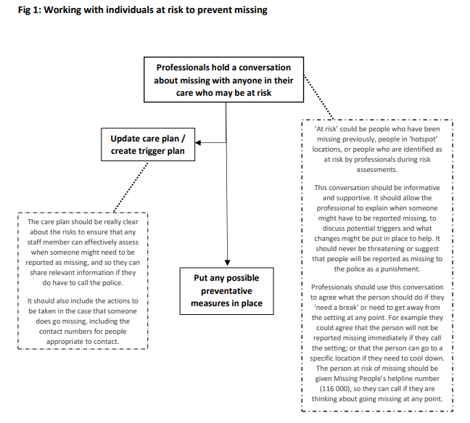

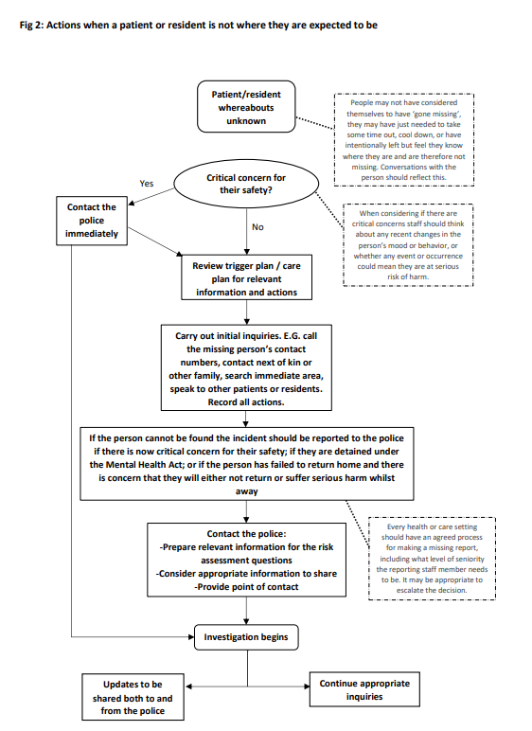

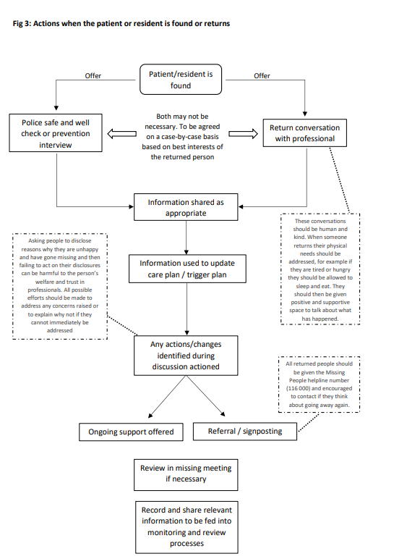

APPENDIX 2
MISSING ADULTS PROTOCOL - NORTHUMBRIA
RETURN HOME INTERVIEW / DISCUSSION SUGGESTED TEMPLATE
This is a suggested template for a return home interview / discussion with an adult who has had a missing episode. It is intended for use by any professional who provides care / support to an adult who has had a missing episode, with the aim of tailoring support for the individual and reducing the likelihood of future missing episodes.
The interview / discussion has two parts. The first is to be completed immediately after the adult returns. The second is to be completed within 72 hours of return where possible, depending upon the health and wellbeing of the adult.
Before asking the below questions, ensure that the adult understands the purpose of the interview / discussion. Explain that information will not be shared unless consent has been given (however information will be shared if there is a public interest i.e. not acting may place other people at risk, or there is a duty of care to intervene, i.e. a crime has been or may have been committed)
Adults Name
Address
DOB
Telephone Number
Gender
Legal Status
Details of any disability / medical condition
ID number (if applicable) | i.e. NHS number

Date adult went missing  interview (RI): |  | Return date:
Details of person conducting the interview (Name, job title, tel no:)

Part one: Immediate Observations
To be completed as soon as the person returns.

Return Details

- What time did the adult return?

- How did the adult return? Taxi? Dropped off, who, what car, registration, make/colour? Police? If a taxi, where did they collect the person from, anyone else there, note the Taxi Company, driver/reg

Presentation

- Was the adult under the influence/intoxicated- what did they take/how much ?

- Is the adult angry/upset. Any physical injuries/health needs/mental health concerns. Is there need for immediate intervention, A&E/Ambulance/crisis team?

- Is the adult wearing different clothes, have anything new with them, hair and makeup done differently?

Disclosure

- Note down anything they may say when they have returned:

- Who was the adult with, where did they go. Any initial information that may be shared by the adult.

- Any criminal disclosure, rape/sexual assault/criminal activity (informed needed about who is to be contacted if any offences are disclosed)

Part two: Interview
To be completed within 72 hours where possible

- What happened to make the adult go missing? Why did you go missing? (Bullying, Domestic Violence, Sexual / Criminal Exploitation, Threat, Control)

- Was it planned?

- What did the adult take with them?

- What happened when the adult when missing, what did the person do?

- Where did the adult stay? If unsure, any street names, descriptions of what is close by, door number/colour. Had they been there before.

- Who was the adult with? Any names, nicknames, ages, how they know them, was there anyone else with them.

- What did the adult do for Food/Money- how did they get about, did they walk or get taxi’s/pubic transport.

- Did the adult have wash whilst missing, change their clothes, where did they do this, how?

- Has any crimes been committed? Did anything happen to adult (assault/threats)

- Did the adult witness anything happen to anyone else? Were they scared of anything or worried about anyone else?

- Did the adult seen anything they didn’t like? Or made them feel uncomfortable?

- Is there anyone the adult is afraid of at the moment, if so who? Why are they afraid

- Did the adult use any drugs/alcohol/legal high, if so how much?

- How did they fund this? Where did they get it from?

- How did the adult get home? Did someone ring the police/call a taxi?

- What made the adult come back?

- What might help the adult to feel safer?

- How does the adult feel about where they are currently living? Anything the adult is worried about.

- How is the adult feeling now they are back?

- What can be done to support the adult not to go missing again?

- Do you consent for information discussed in this interview to be shared with the Northumbria Police Missing Persons team?

Information from return home interviews should be shared with Police with consent to allow for a problem solving approach to be taken to the Missing episode ( Email to MissingPersonMailbox@northumbria.pnn.police.uk ) Unless there are reasons to override consent, then consent should be obtained.

APPENDIX 3
MISSING ADULTS PROTOCOL - NORTHUMBRIA
LOCAL REFERRAL PATHWAYS – [Name of Area]
Referral Pathway | Service Detail | Referral Details  (Include Telephone number, email, website, online reporting)
Local Authority | Main Switchboard
 | Adult Social Care
 | Safeguarding Adults
 | Emergency Duty Team
 | Housing Advice
 | Leaving Care Team
 | Domestic Abuse Team
MASH
(Multi-Agency Safeguarding Hub)
Substance Misuse Service | [Name of Service]
Mental Health Crisis | [Name of Service]
………….. | [Name of Service]

