Edition No 1

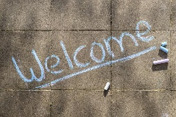
to the very first edition of the Newcastle Adults and Children Safeguarding Newsletter! The aim of the newsletter is to give you a brief overview of news items, training and learning opportunities, examples of good practice and anything else the Safeguarding Adults Board and Safeguarding Child Partnership think you would find helpful. The newsletter will be produced quarterly initially and we’d love for our partners to contribute. We will be looking for children and young people to help shape, write and edit our future editions.

The Independent Review of Children’s Social Care carried out by Josh MacAlister has just been published and is “the most wide ranging rethink of children’s social care in more than a generation”. Click here for the full report.

The NSAB have recently published a Safeguarding Adults Review (SAR). To read the SAR click here.

White Ribbon UK are part of a global campaign to end male violence against women and girls. They do this by encouraging men and boys to take action to change behaviour and culture that leads to abuse and violence. Click here for more information about how you can get involved.

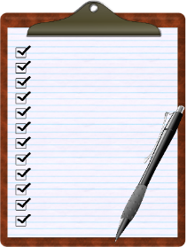
Ofsted’s review into sexual abuse in schools and colleges – following a survey to schools, Newcastle Safeguarding Children Partnership (NSCP) has opened a quick survey for local businesses and the community and voluntary sector. Peer on peer sexual abuse and harassment doesn’t only happen in educational settings so the aim of the survey is to get an idea of the third sector’s awareness of the issue and what support the Partnership can offer organisations. Please click here to access the survey.
Surveys &
Consultations

The Newcastle Safeguarding Adults Board (NSAB) self-neglect practitioner survey has just closed. The purpose of the survey is for the NSAB to try to further
understand practitioner experiences of self-neglect to inform any changes that might be made to policy, practice and training. For more information click here and keep your eyes open for the findings!

The Government has opened a consultation setting out the proposed updates to the Mental Capacity Act (MCA) Code of Practice and implementation of the Liberty Protection Safeguards (LPS) which runs to 7 July 2022. Click here for more information.

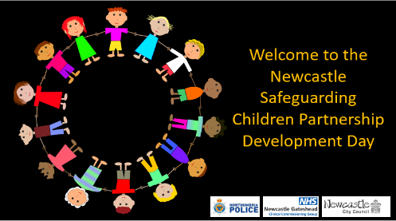
The NSCP held their Development Day in March. The focus of the day was the voice of the child with participants hearing children and young people’s experiences and perceptions on a number of safeguarding issues. Click on the image to see the slides from the day.

Spotlight on Training – The NSAB and NSCP offer both safeguarding courses as well as other training programmes and resources. This edition is going to put the spotlight on a new course delivered by Mike Ward from Alcohol Change UK on the MCA and Vulnerable Dependent Drinkers. This workshop is aimed at staff and volunteers who work with people who are at risk of alcohol-related harm and will cover the MCA and other legal powers available to protect vulnerable dependent drinkers. Click here for dates, aims, objectives and target audience information.

And finally ………! the NSCP has a new logo!

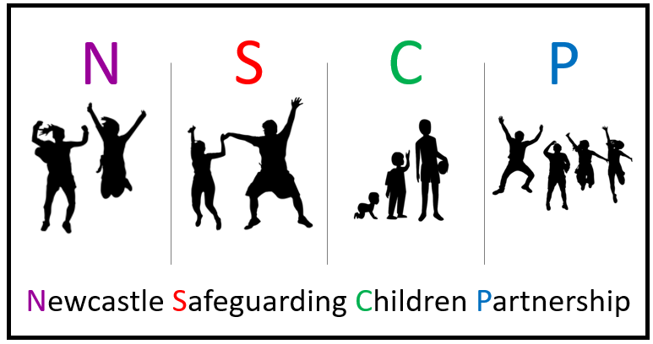

A big THANK YOU to students at Jesmond Park Academy who gave the Partnership some great logo designs and ideas. Elements from several of the designs were used to produce four logos which were voted on by partners and relevant agencies. The voting was close but this one just came out on top. We hope you all like it!
If you have news, examples of good practice, videos or biteables you’d like to be included in the next newsletter please send them to claire.nixon@newcastle.gov.uk (adults) or tina.lisle@newcastle.gov.uk (children).

