Appendices 1 to 3: adult safeguarding decision guide, body map and concern proforma
Published 5 March 2024

Contents
Appendix 1: adult safeguarding decision guide 2
Appendix 2: body map 13
Appendix 3: adult safeguarding concern proforma regarding pressure ulceration 15

This is a fictious case example used for educational purposes.

Appendix 1: adult safeguarding decision guide
You should review all 6 questions and see the score conclusion.

Person's information
Person's name: Elizabeth Bloggs
Person's NHS number: 123 123 4567

Assessor information
Assessing nurse’s name (print): Florence Nightingale
Job title: Registered Nurse
Assessing nurse’s signature: F. Nightingale
Note: when using an electronic patient record (EPR), this guide will be completed under one assessor's profile. However, if there is a second assessor present, you should record their name.
Second assessor’s name (print): Mary Seacole
Job title: Registered Nurse
Second assessor’s signature: M. Seacole

Question 1
Has the person's skin deteriorated to either category 3 or 4 or multiple sites of category 2 ulceration from healthy unbroken skin since the last opportunity to assess or visit?
Level of concern | Score | Evidence
Yes  For example, record of blanching or non-blanching erythema progressing to category 2 or category 2 progressing to category 3 or 4 | 5 | For example, evidence of redness or skin breaks with no evidence of provision of repositioning or pressure relieving devices provided  Known to district nursing team - Category 3 pressure ulcer to left heel present for some time now but is continually deteriorating. Reports of self neglect at home, safeguarding has been submitted by the DN team regarding this.  Note history of Lymphoedema and Elizabeth declining to wear compression hosiery. General decline in condition - both physically and cognitively. Reduction in mobility reported to GP by both district nursing team and care provider.
No  For example, no previous skin integrity issues or no previous contact health or social care services | 0

Question 2
Has there been a recent change, that is within days or hours, in their clinical condition that could have contributed to skin damage?
For example, infection, pyrexia, anaemia, end of life care (skin changes at life end), critical illness, emergency hospital visit.
Level of concern | Score | Evidence
Change in condition contributing to skin damage | 0 | Admitted to hospital.  Confirmed sepsis - possible chest or urine but left heel ulcer also suspected as potential cause.  Expectorating thick, green sputum with cough.  Necrosis to heel - however podiatry input to debride this and blistered area, although the ulcer is categorised as a category 3 is does not appear deep from observation of wound photography. X-Ray has been performed to rule out osteomyelitis and MRI has also been considered. Orthopaedics team also consulted.
No change in condition that could  contribute to skin damage | 5

Question 3
Was there a pressure ulcer risk assessment or reassessment with an appropriate pressure ulcer care plan in place, and was this documented in line with the organisation’s policy and guidance?
Level of concern | Score | Evidence
Yes, current risk assessment and care plan carried out by a healthcare professional and documented appropriate to person's needs  If the person is not under the care of a healthcare professional, the carer responsible has screened for risk and implemented preventative care accordingly | 0 | State date of assessment, risk tool used and score or risk level  On 03/04/25 Score 12 (High Risk).  The district nursing team have undertaken regular risk assessment and have provided preventative equipment in alignment with risk level.  Documented evidence of equipment provided by the district nursing team.  Airflow mattress installed on an electric profiling bed frame but Elizabeth does not use this consistently, preferring to sleep in her armchair.  Pressure redistributing cushion installed on armchair.  Education documented within the patient notes as being provided verbally by the district nursing team.  Patient information leaflets also provided to Elizabeth.
Yes, risk assessment carried out and care plan in place documented but not reviewed as person’s needs have changed | 5 | State the elements of care plan that are in place
No or incomplete risk assessment and/or care plan carried out | 15 | State the elements that would have been expected to be in place but were not

Question 4
Is there a concern that the pressure ulcer developed as a result of the informal carer wilfully ignoring or preventing access to care or services?
Level of concern | Score | Evidence
No or not applicable | 0 | No evidence or concern.  Patient notes evidence that both the district nursing team and care provider were regularly in contact with each other and also with the GP and social worker.
Yes | 15

Question 5
Is the level of damage to skin inconsistent with the person's risk status for pressure ulcer development?
For example, no risk factors that align with the category of pressure ulcer that has developed.
Level of concern | Score | Evidence
Skin damage less severe than person's risk assessment suggests is proportional | 0 | The patient's condition prior to and on admission to hospital is consistent with the picture presented in the patient record and level of risk.
Skin damage more severe than person's risk assessment suggests is proportional | 10

Question 6
Question 6 has 2 parts - which part you ask depends on the person:
- if the person has capacity to consent to every relevant element of the care plan, answer question 6a
- if the person has been assessed as not having mental capacity to consent to any or some relevant aspects of the care plan, answer 6b

Question 6a
Were the risks and benefits explained and understood by the person?

Was a plan of care agreed in line with shared decision making and has the person chosen to follow the relevant aspects of the plan?
Level of concern | Score | Evidence
Person has followed care plan, and local policies to support shared decision making have been followed | 0
Person followed some aspects of care plan but not all | 3
Person has not followed care plan or not given information to enable them to make an informed choice, or an opportunity to discuss reasons for not following the agreed plan and alter the plan accordingly has not been taken | 5

Question 6b
Was the relevant care undertaken in the person's best interests, following the best interests checklist in the Mental Capacity Act?
This should be supported by documentation - for example, capacity and best interest statements and record of care delivered.
Level of concern | Score | Evidence
Documentation of care being undertaken in person’s best interests | 0 | Some question around patient capacity. On review of notes it would appear that although Elizabeth has capacity around making simple day to day decisions, she may not have capacity around complex decision making, particularly those around her healthcare needs.  Documented in notes that Elizabeth has been using both challenging behaviours and presentations to refuse care and medical interventions.
No documentation of care being undertaken in person’s best interests | 10

Score conclusion
If the total score is 15 or over, discuss with the local authority (safeguarding) as determined by local procedures and reflecting the urgency of the situation.
When the decision guide has been completed, even when there is no indication that a safeguarding alert needs to be raised, the tool should be stored in the person's notes.

Appendix 2: body map
Body maps should be used to record skin damage and can be applied as evidence, if necessary, at a later date.
If 2 workers observed the skin damage, they should both sign the body map.

Person's information
Person's name: Elizabeth Bloggs
Person's NHS number: 123 123 4567

Assessor information
Assessing nurse’s name (print): Florence Nightingale
Job title: Registered Nurse
Assessing nurse’s signature: F. Nightingale
Note: when using an electronic patient record (EPR), this guide will be completed under one assessor's profile. However, if there is a second assessor present, you should record their name.
Second assessor’s name (print): Mary Seacole
Job title: Registered Nurse
Second assessor’s signature: M. Seacole
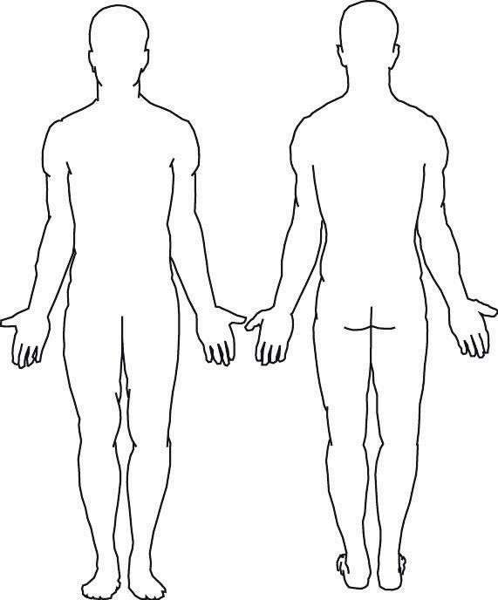

Appendix 3: adult safeguarding concern proforma regarding pressure ulceration
Fill this form in if the adult safeguarding decision guide score is 15 or over.

Person's information
First name:
Last name:
Date of birth:
NHS number:
Address:

Assessor information
Department or base address:
Organisation name:
Telephone number:
Assessing nurse’s name (print):
Job title:
Assessing nurse’s signature:
Note: when using an electronic patient record (EPR), this guide will be completed under one assessor's profile. However, if there is a second assessor present, you should record their name.
Second assessor’s name (print):
Job title:
Second assessor’s signature:
Date and time assessors witnessed pressure ulceration:
Date and time of completing documentation of concern:

© Crown copyright 2024
www.gov.uk/dhsc
This publication is licensed under the terms of the Open Government Licence v3.0 except where otherwise stated. To view this licence, visit nationalarchives.gov.uk/doc/open-government-licence/version/3.
Where we have identified any third party copyright information you will need to obtain permission from the copyright holders concerned.


