Appendices 1 to 3: adult safeguarding decision guide, body map and concern proforma
Published 5 March 2024

Contents
Appendix 1: adult safeguarding decision guide 2
Appendix 2: body map 13
Appendix 3: adult safeguarding concern proforma regarding pressure ulceration 15

This is a fictious case example used for educational purposes.

Appendix 1: adult safeguarding decision guide
You should review all 6 questions and see the score conclusion.

Person's information
Person's name: Ishaan Patel
Person's NHS number: 234 123 4567

Assessor information
Assessing nurse’s name (print): Florence Nightingale
Job title: Registered Nurse
Assessing nurse’s signature: F. Nightingale
Note: when using an electronic patient record (EPR), this guide will be completed under one assessor's profile. However, if there is a second assessor present, you should record their name.
Second assessor’s name (print): Mary Seacole
Job title: Registered Nurse
Second assessor’s signature: M. Seacole

Question 1
Has the person's skin deteriorated to either category 3 or 4 or multiple sites of category 2 ulceration from healthy unbroken skin since the last opportunity to assess or visit?
Level of concern | Score | Evidence
Yes  For example, record of blanching or non-blanching erythema progressing to category 2 or category 2 progressing to category 3 or 4 | 5 | For example, evidence of redness or skin breaks with no evidence of provision of repositioning or pressure relieving devices provided  Category 2 pressure ulceration to sacrum, deteriorating to Category 4 in the last 7 days.
No  For example, no previous skin integrity issues or no previous contact health or social care services | 0

Question 2
Has there been a recent change, that is within days or hours, in their clinical condition that could have contributed to skin damage?
For example, infection, pyrexia, anaemia, end of life care (skin changes at life end), critical illness, emergency hospital visit.
Level of concern | Score | Evidence
Change in condition contributing to skin damage | 0 | .
No change in condition that could  contribute to skin damage | 5 | Medical history of diabetes and frailty.  Patient had experienced significant reduction in mobility and required increasing assistance with personal care necessitating admission to nursing home 6 months ago.

Question 3
Was there a pressure ulcer risk assessment or reassessment with an appropriate pressure ulcer care plan in place, and was this documented in line with the organisation’s policy and guidance?
Level of concern | Score | Evidence
Yes, current risk assessment and care plan carried out by a healthcare professional and documented appropriate to person's needs  If the person is not under the care of a healthcare professional, the carer responsible has screened for risk and implemented preventative care accordingly | 0 | State date of assessment, risk tool used and score or risk level
Yes, risk assessment carried out and care plan in place documented but not reviewed as person’s needs have changed | 5 | State the elements of care plan that are in place
No or incomplete risk assessment and/or care plan carried out | 15 | State the elements that would have been expected to be in place but were not  Assessed as high risk of pressure ulceration at most recent reassessment.  Documentation shows no evidence of repositioning or pressure relief over the past week.  Care plans undertaken previously state that Mr Patel should be repositioned every two hours, but this has not been undertaken consistently.  No pressure-relieving mattress or cushion was provided, despite his high risk.

Question 4
Is there a concern that the pressure ulcer developed as a result of the informal carer wilfully ignoring or preventing access to care or services?
Level of concern | Score | Evidence
No or not applicable | 0 | No evidence or concern.  Mr Patel’s care is provided by paid carers.
Yes | 15

Question 5
Is the level of damage to skin inconsistent with the person's risk status for pressure ulcer development?
For example, no risk factors that align with the category of pressure ulcer that has developed.
Level of concern | Score | Evidence
Skin damage less severe than person's risk assessment suggests is proportional | 0 | Level of skin damage (category 4 pressure ulceration) is proportionate to previously assessed high level of risk.  However, the risk of developing such significant pressure damage may have been prevented had preventative interventions been implemented.
Skin damage more severe than person's risk assessment suggests is proportional | 10

Question 6
Question 6 has 2 parts - which part you ask depends on the person:
if the person has capacity to consent to every relevant element of the care plan, answer question 6a
if the person has been assessed as not having mental capacity to consent to any or some relevant aspects of the care plan, answer 6b

Question 6a
Were the risks and benefits explained and understood by the person?

Was a plan of care agreed in line with shared decision making and has the person chosen to follow the relevant aspects of the plan?
Level of concern | Score | Evidence
Person has followed care plan, and local policies to support shared decision making have been followed | 0
Person followed some aspects of care plan but not all | 3
Person has not followed care plan or not given information to enable them to make an informed choice, or an opportunity to discuss reasons for not following the agreed plan and alter the plan accordingly has not been taken | 5 | Mr Patel was in agreement with the proposed care plan, but was reliant on the care home team to undertake the interventions necessary to prevent skin damage from occurring.

Question 6b
Was the relevant care undertaken in the person's best interests, following the best interests checklist in the Mental Capacity Act?
This should be supported by documentation - for example, capacity and best interest statements and record of care delivered.
Level of concern | Score | Evidence
Documentation of care being undertaken in person’s best interests | 0
No documentation of care being undertaken in person’s best interests | 10

Score conclusion
If the total score is 15 or over, discuss with the local authority (safeguarding) as determined by local procedures and reflecting the urgency of the situation.
When the decision guide has been completed, even when there is no indication that a safeguarding alert needs to be raised, the tool should be stored in the person's notes.

Appendix 2: body map
Body maps should be used to record skin damage and can be applied as evidence, if necessary, at a later date.
If 2 workers observed the skin damage, they should both sign the body map.

Person's information
Person's name: Ishaan Patel
Person's NHS number: 234 123 4567

Assessor information
Assessing nurse’s name (print): Florence Nightingale
Job title: Registered Nurse
Assessing nurse’s signature: F. Nightingale
Note: when using an electronic patient record (EPR), this guide will be completed under one assessor's profile. However, if there is a second assessor present, you should record their name.
Second assessor’s name (print): Mary Seacole
Job title: Registered Nurse
Second assessor’s signature: M. Seacole
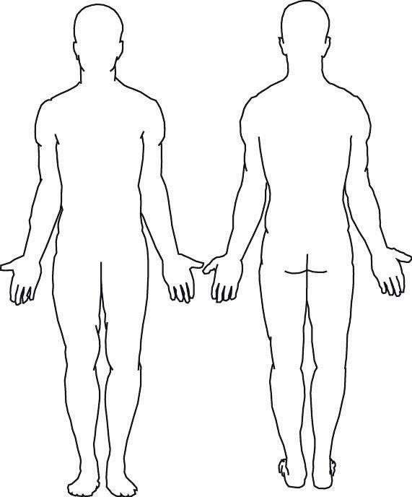

Appendix 3: adult safeguarding concern proforma regarding pressure ulceration
Fill this form in if the adult safeguarding decision guide score is 15 or over.

Person's information
First name: Ishaan
Last name: Patel
Date of birth: 06/02/1950
NHS number: 234 123 4567
Address: 12 Ischial Avenue, Newcastle. NE4 4BW

Assessor information
Department or base address: The Lantern Centre, Newcastle. NE6 4PU
Organisation name: The Royal Victoria Infirmary, Newcastle. NE1 4LP
Telephone number: 0191 233 6161
Assessing nurse’s name (print): Florence Nightingale
Job title: Registered Nurse
Assessing nurse’s signature: F. Nightingale
Note: when using an electronic patient record (EPR), this guide will be completed under one assessor's profile. However, if there is a second assessor present, you should record their name.
Second assessor’s name (print): Mary Seacole
Job title: Registered Nurse
Second assessor’s signature: M. Seacole
Date and time assessors witnessed pressure ulceration: 03/04/2025 09:00
Date and time of completing documentation of concern: 03/04/25 15:35

© Crown copyright 2024
www.gov.uk/dhsc
This publication is licensed under the terms of the Open Government Licence v3.0 except where otherwise stated. To view this licence, visit nationalarchives.gov.uk/doc/open-government-licence/version/3.
Where we have identified any third party copyright information you will need to obtain permission from the copyright holders concerned.


